**Week5 -RANSAC Lab sheet (2)**

**In order to work on this lab you need to download ‘Ransac.ipynb’ from LZ. Additionally, you need to read ‘**RANSAC_pseudocode’ doc **on LZ. You could use google colab.**

Here is a screenshot of the complete working program:

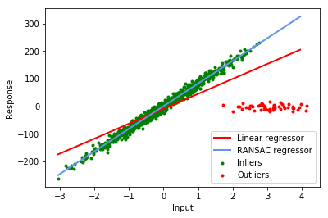

The data points are in red and green. The green data points are those which are in the best ConsensusSet vector. The red line is drawn using the two parameters in LLSModel – the Linear Least Squares Model from all the data. The blue line is drawn using the two parameters in bestModel – the linear least squares model from all the best consensus set (the green dots). The model we are fitting to is a straight line in the form y=mx+c, the parameters of this model are the two floating point numbers m and c.

To get the program working you will have to complete the implementation of the following functions in the attached code, i.e. ‘Ransac.ipynb’:

-**linearLeastSquares(fittingData)**: In this function you are passed the data, (X, y) which is to be fitted to the model. Implement ‘Linear Least Squares Estimate’, and return params[0] as m and params[1] as c. Test this function using the randomly created data. If you use all the data, included outlier, this will produce the red line in the figure. You could also implement the Pearson correlation here and return this number. Please see the Lesson 1 lecture to know how to implement Linear Least Squares Estimate.

**modelFitness( modelData, params)**: In this function you passed some data and a model parameters (m and c). You should calculate the RMSE of the data to the model and return this number. Given that the model is y=mx+c you can use the following to calculate the error of a single data point:

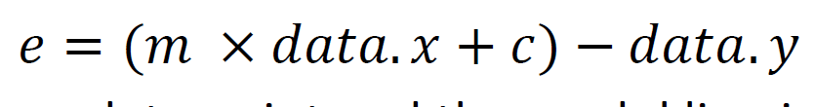

This gives the distance between data point and the model line in the y axis.

In the next step you can use the previous functions to write code for RANSAC algorithm. Use the Pseudocode provided as a basis for your code:

|  |
| --- |
|  |

Linear Least Squares Estimate from lecture 1:

